**For using low complexity implementation**

Develop as planned. Don’t use checkpoints is ok. Ability to not use checkpoints

Final go live to include some checkin locations

Experiment to see if ‘enforcement’ is needed, by varying placement of checkin station and design of instructions and design of station

Determine % of people who don’t scan, and characteristics of people. Eg age

Use equipment which hospital already have to reduce cost of increasing from low to medium complexity

Computer + scanner

Tablet – make sure can scan

Pi?

OCR for NRIC?

USB Thermometer?

On registration form, How to verify visitor’s entry of patient and bed number? – query patient DB and get patient name. as long as any part of the patient name matches entered name, validated. Eg.Patient name is tan ah kee. If “ah” is entered into patent name field, allow.

Registration is daily. 1 registration can allow multiple visits per day.

Master list of beds

What other visits? Location dropdown list. Need reason?

Entrance checkpoint needs validation that user has registered and approved. Also check that the visitor per patient limit

SIT Testing documents

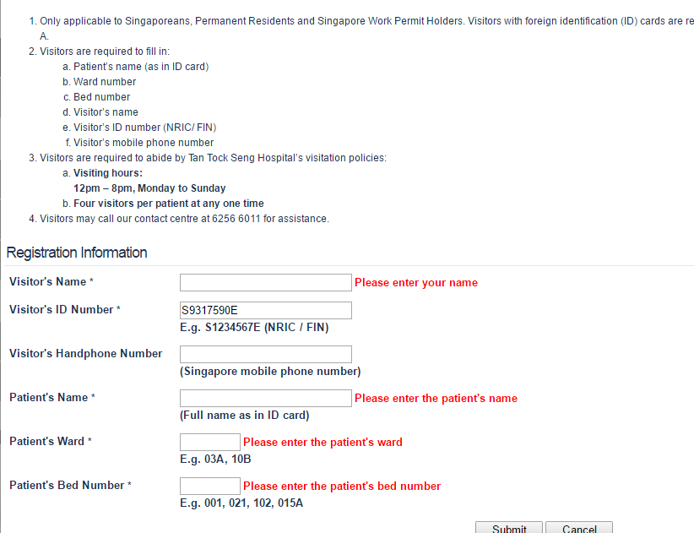<https://www.ttsh.com.sg/visitorregistration/>

<https://www.ttshvfsonline.ttsh.com.sg/>

Only applicable to Singaporeans, Permanent Residents and Singapore Work Permit Holders. Visitors with foreign identification (ID) cards are required to register at the service counter located at Level 1 or Basement 1, Lift lobby A.

Market Research

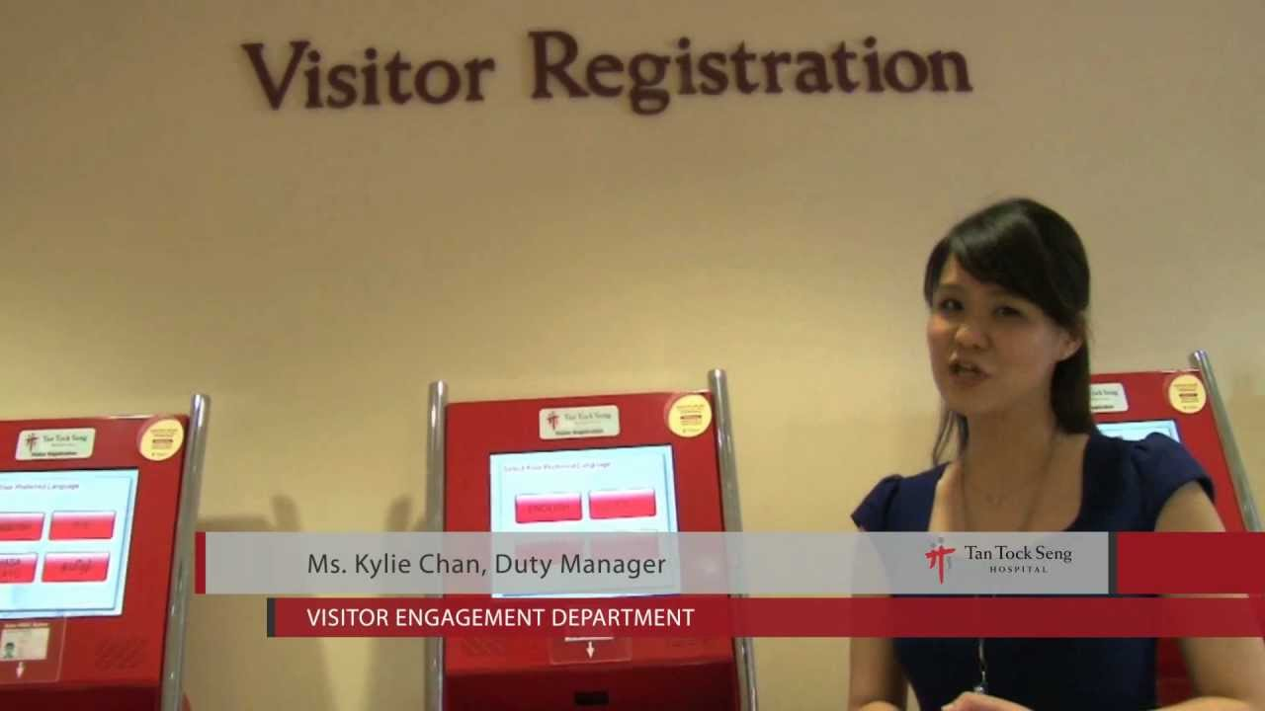<https://www.youtube.com/watch?v=h-nNvv8jDUs> public school

<https://www.youtube.com/watch?v=tMGUzwgZC58>

iLobby visitor <https://goilobby.com/pricing>

<http://www.usetouchpoint.com.sg/visitor-management.htm>

<http://www.swipedon.com/pricing.html>

<http://www.tagz.com.sg/promo/>

Not catered for medical / contact tracing purpose

<https://www.ntfgh.com.sg/Patients_and_Visitors/Visiting_Patients.aspx>

https://www.sgh.com.sg/patient-services/other-admin-services/pages/visitor-management-system.aspx

http://apps.singhealth.com.sg/avmsonline/

<https://www.sgh.com.sg/patient-services/other-admin-services/pages/visitor-management-system-faq.aspx>

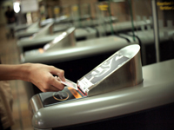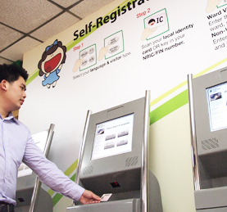

Making fun of logging

<https://www.youtube.com/watch?v=YjuJOvdxhwU>

ihis

<https://www.ihis.com.sg/Procurement/Pages/Procurement_RFPList.aspx>

Purpose of the systems